Absorb Bioresorbable Vascular Scaffold System

Overview
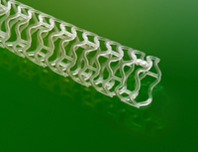

Absorb, the 4th Revolution in Interventional Cardiology
Absorb is a Bioresorbable Vascular Scaffold (BVS) system that elutes everolimus in a similar way to XIENCE V and then resorbs naturally into the body leaving no permanent scaffold*. Absorb is comprised of four key design elements: a bioresorbable scaffold, a bioresorbable coating, everolimus and the XIENCE V delivery system.

Absorb Design Elements†
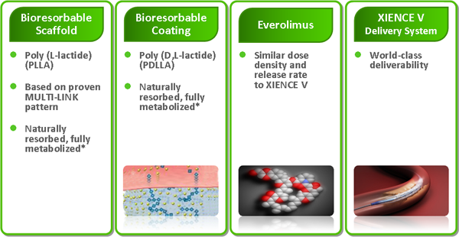
Absorb defines a new paradigm - Vascular Reparative Therapy (VRT). VRT is designed to restore the vessel to a more natural state§, making natural vascular function possible. While stenting performance is characterized by a single phase of revascularisation, Absorb was designed with the premise of working in three phases to deliver VRT:
- Revascularisation
- Restoration
- Resorption
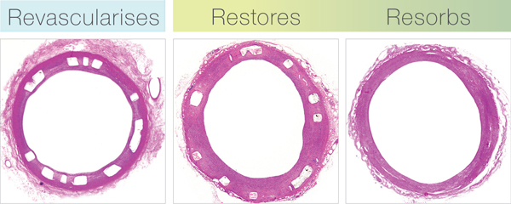
Revascularisation
In the Revascularisation phase, Absorb revascularises like a best in class DES, XIENCE. Absorb achieves this goal by offering good deliverability, excellent conformability, a minimum of acute recoil, high radial strength, and controlled release of the anti-proliferative drug everolimus to minimise neointimal growth.
Restoration & Resorption
The goal of the restoration phase is to enable natural vessel function for improved long-term outcomes. Restoration of the vessel occurs as the scaffold benignly resorbs without inflammation. Absorb gradually ceases providing luminal support and evolves from an intact scaffold to a discontinuous structure embedded within neointimal tissue. As the scaffold degrades, the polymer is converted into lactic acid which is metabolised through the Krebs cycle and is ultimately converted into benign by-products of carbon dioxide and water.
*Small platinum markers at scaffold edges remain for fluoroscopic landmarking.
†All illustrations are artists’ renditions.
§Versus current standard of care, DES.
Features
Vascular Reparative Therapy (VRT) Heralds a New Era in Interventional Cardiology
The development of Bioresorbable Vascular Scaffolds was based on the premise that scaffolding and drug delivery to the diseased coronary vessel are only required on a temporary basis following coronary interventions. Several studies support this concept and indicate that there is no incremental clinical benefit of a permanent implant over time¹⁻⁷. Absorb, the world’s first commercially available drug-eluting coronary Bioresorbable Vascular Scaffold (BVS), is designed to deliver Vascular Reparative Therapy (VRT) by eliminating the presence of a permanent mechanical restraint*. Vascular Reparative Therapy allows for mechanical conditioning, vasomotion and late lumen gain⁸. Preliminary evidence of vasomotion suggests that natural vessel function is possible to achieve improved long-term outcomes⁹. Late lumen gain has the potential for reduced TLR by maintaining a widely patent lumen¹⁰. The goal of VRT is to ultimately return the vessel back to a more natural state§ with the possibility for delayed disease progression and improved angina control.

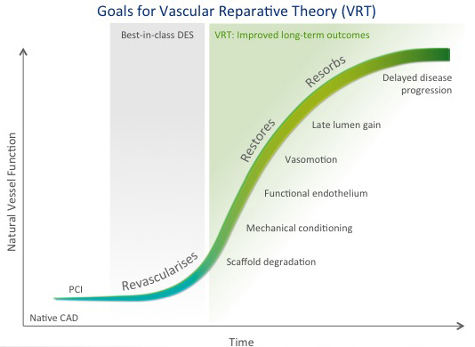
*Small platinum markers at scaffold edges remain for fluoroscopic landmarking.
§Versus current standard of care, DES.
1. Serruys PW, et al. A comparison of balloon-expandable-stent implantation with balloon angioplasty in patients with coronary artery disease. Benestent Study Group. N Engl J Med 1994;331(8):489-95.
2. Serruys PW, et al. Incidence of restenosis after successful coronary angioplasty: a time-related phenomenon. A quantitative angiographic study in 342 consecutive patients at 1, 2, 3, and 4 months. Circulation 1988;77(2):361-71.
3. Nobuyoshi M, et al. Restenosis after successful percutaneous transluminal coronary angioplasty: serial angiographic follow-up of 229 patients. J Am Coll Cardiol 1988;12(3):616-23.
4. Asakura M, et al. Remodeling of in-stent neointima, which became thinner and transparent over 3 years: serial angiographic and angioscopic follow-up. Circulation 1998;97(20):2003-6.
5. Witkowski A, et al. A randomized comparison of elective high-pressure stenting with balloon angioplasty: six-month angiographic and two-year clinical follow-up. On behalf of AS (Angioplasty or Stent) trial investigators. Am Heart J 2000;140(2):264-71.
6. Betriu A, et al. Randomized comparison of coronary stent implantation and balloon angioplasty in the treatment of de novo coronary artery lesions (START): a four-year follow-up. J Am Coll Cardiol 1999;34(5):1498-506.
7. Kandzari DE, et al. Comparison of long-term (seven year) outcomes among patients undergoing percutaneous coronary revascularization with versus without stenting. Am J Cardiol 2006;97(10):1467-72.
8. Serruys PW, et al. From metallic cages to transient bioresorbable scaffolds: change in paradigm of coronary revascularization in the upcoming decade? Eur Heart J 2012;33(1):16-25b.
9. ABSORB Cohort A 24-month and ABSORB Cohort B 12-month vasomotor function testing.
10. Between six months and two years in ABSORB Cohort B.
Clinical Data
- Complete scaffold resorption* by year 3 provides unique clinical benefits
- ABSORB II Randomized Clinical Trial
- 1 Year results of ABSORB II demonstrate proven safety and effectiveness with unique long-term benefits
- Absorb continues the trend toward consistent improvement in PCI outcomes
- Absorb delivers significant reduction in post-PCI angina

Complete scaffold resorption* by year 3 provides unique clinical benefits
Absorb Revascularizes like a best in class DES, Restores the vessel and Resorbs. Restored vascular function and improved coronary flow provide unique benefits such as:
- Lumen gain¹
- Plaque regression¹
- Vasomotion¹
- Reduction of late events²
- Reduction of post-PCI angina³
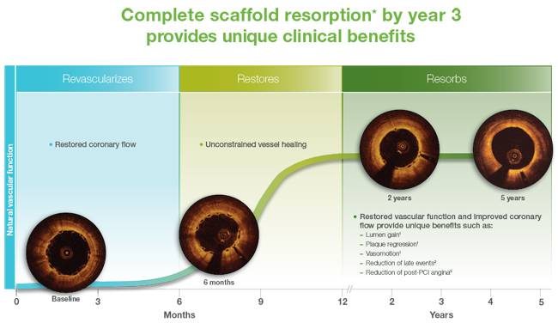
OCT images from ABSORB Cohort B. Courtesy of RJ van Geuns, Erasmus Medical Center, Rotterdam.
*Small platinum markers at scaffold edges remain for fluoroscopic landmarking.
_{References:}
1. Serruys P. Cohort B 3 Year Clinical and Imaging Results. Presented at the 62nd Annual Scientific Session of the ACC, 9-11 Mar 2013, San Francisco.
2. Smits P. EXTEND 3 Year Presentation. Presented at TCT 2014, 13-17 Sep 2014, Washington, DC.
3. Serruys P. ABSORB II 1 Year Clinical Outcomes. Presented at TCT 2014,13-17 Sep 2014, Washington, DC.

ABSORB II Randomized Clinical Trial
ABSORB II is the first randomized clinical trial of a bioresorbable scaffold.
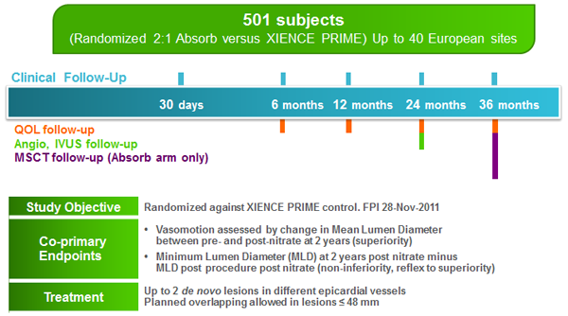

1 Year results of ABSORB II demonstrate proven safety and effectiveness with unique long-term benefits
ABSORB II is the first randomized clinical trial of a bioresorbable scaffold.
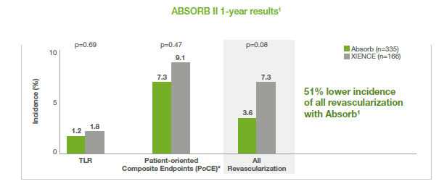

Absorb continues the trend toward consistent improvement in PCI outcomes
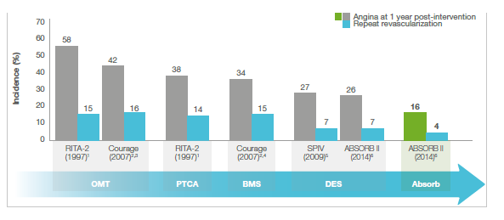

Absorb delivers significant reduction in post-PCI angina
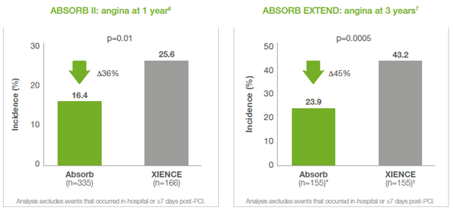
* EXTEND. Excludes non-Japanese Asians.
_{† SPIRIT IV. Matched patients.}
_{References:}
1. RITA-2 trial participants. Lancet. 1997;350:461-8. [Repeat revascularization rates estimated from the Kaplan-Meier curve.]
2. Boden WE, et al. N Engl J Med. 2007;356:1503-16.
3. Spertus JA, et al. Circ Cardiovasc Qual Outcomes. 2013;6:409-18.
4. http://www.cathlabdigest.com/articles/The-COURAGE-Trial-Looking-pastcontroversy-patient-care. Accessed 3 Sep 2014.
5. Stone GW. SPIRIT IV. Presented at TCT 2013, 27 Oct – 1 Nov 2013, San Francisco.
6. Serruys P. ABSORB II 1 Year Clinical Outcomes. Presented at TCT 2014, 13-17 Sep 2014, Washington, DC.
7. Smits P. EXTEND 3 Year Presentation. Presented at TCT 2014, 13-17 Sep 2014, Washington, DC.

Post PCI Angina

Post PCI angina

Ordering Information
Absorb is available in seven sizes.
